Thank you for interest and support of the Southern Nevada Rock Association. Our membership dues allow SNRAA to provide quality lecturers at our monthly meetings.

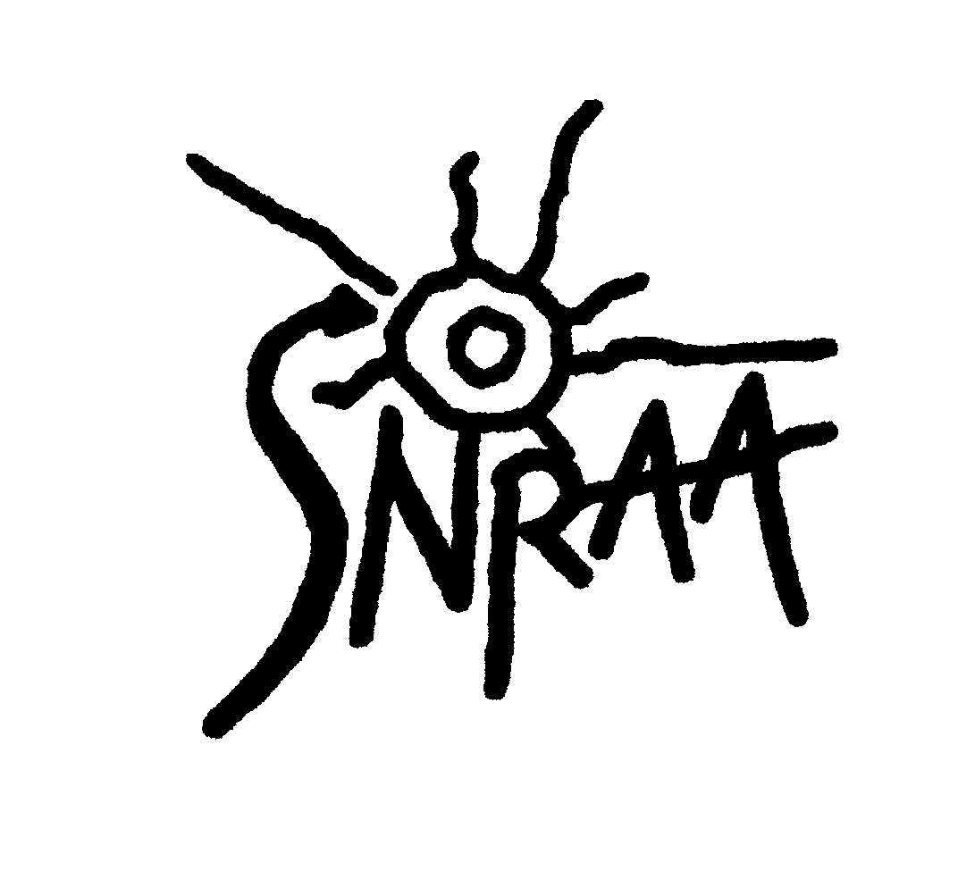
Membership runs annually, from January 1 through December 31. Membership dues are: $20 for an Individual and $25 for a Family. Please furnish an e-mail address which will allow for e-mail updates and periodic PDF attachments.* Please direct inquiries regarding membership via e-mail at snraamail@gmail.com or go to our website at www.SNRAA.org.

Dues should be made payable to: Southern Nevada Rock Art Association (SNRAA) c/o Dennis Robinson, Treasurer at 8510 West Washburn Rd., Las Vegas, NV 89149.

Name: ______________________________________________________________________________
Name(s) of additional family members joining: __________________________________________
Address: _____________________________________________________________________________
E-mail address: ________________________________________________________________________
Main Phone: ____________________________ Alternate Phone: ________________________

Membership type: New membership Renewal Single $20.00 Family $25.00

By signing this form, members agree to abide by the following strict SNRAA policies below:

Petroglyphs and pictographs may be photographed. You agree not to touch, trace, chalk, or otherwise disturb any rock art site in any way.
Rock art sites are usually, if not always, associated with areas of archaeological value. These include rock shelters, agave roasting pits, lithic flakes, sherds, middens, and other features. All archaeological artifacts more than 50 years old (including, but not limited to lithic flakes, ceramics, arrowheads, manos, metates, axe heads) must be returned to the exact location where they were found.
Members participate at their own risk. SNRAA accepts no responsibility for personal or vehicle injury or damages of any kind.
In an effort to protect archaeological and rock art sites from vandalism, member(s) support(s) a “no-publish” policy regarding site information/directions.

Signature: __________________________________________________ Date: ____________

Additional Signature: _________________________________________ Date: ____________

©2017, SNRAA. All Rights Reserved.

